KO88 -

Functionality
During Production order settlement, either Work In Process (if incomplete delivery) or Variance (if complete delivery) is posted. If Variance is posted, any WIP posted before will be reversed.

Scenario
You want to post WIP or Variance after WIP & Variance calculation.

Requirements
Work In Process and Variance was calculated

Menu Path | Accounting →Controlling →Product Cost Controlling → Cost Object Controlling → Product Cost by Order → Period-End Closing → Single Functions → Settlement → KO88 - Individual Processing
Transaction Code | KO88

1. Double click on KO88 - Individual Processing

Actual Settlement: Order

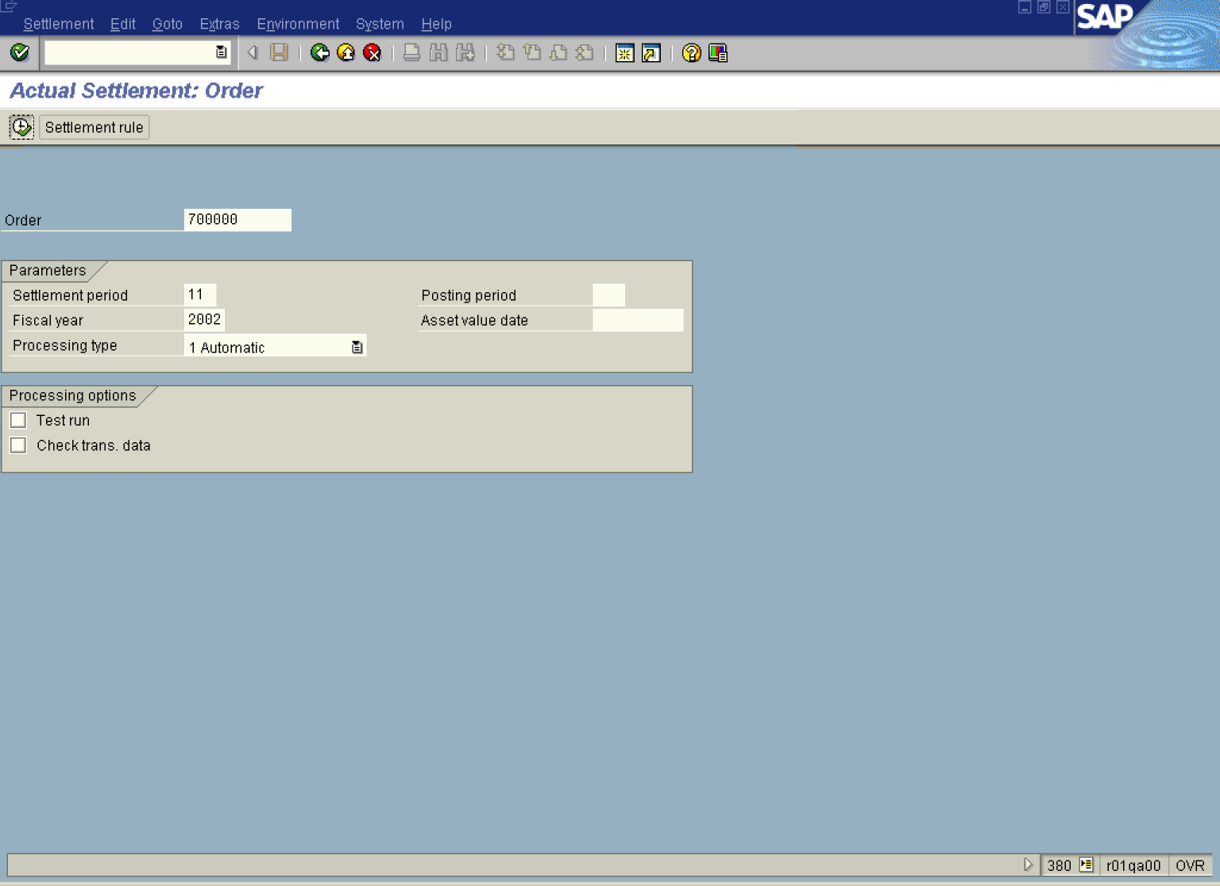

2. Update the following fields:

Field Name | Field Description | Values
Order | Number identifying the order | Example: 700000
Period | Number identifying a fiscal month. | Example: 11
Fiscal year | Fiscal year for which you calculate variance. | Example: 2002

3. Click the Test run checkbox.
4. Click the Execute button.
5. Click the Detail lists button.

Actual Settlement: Order Detail list

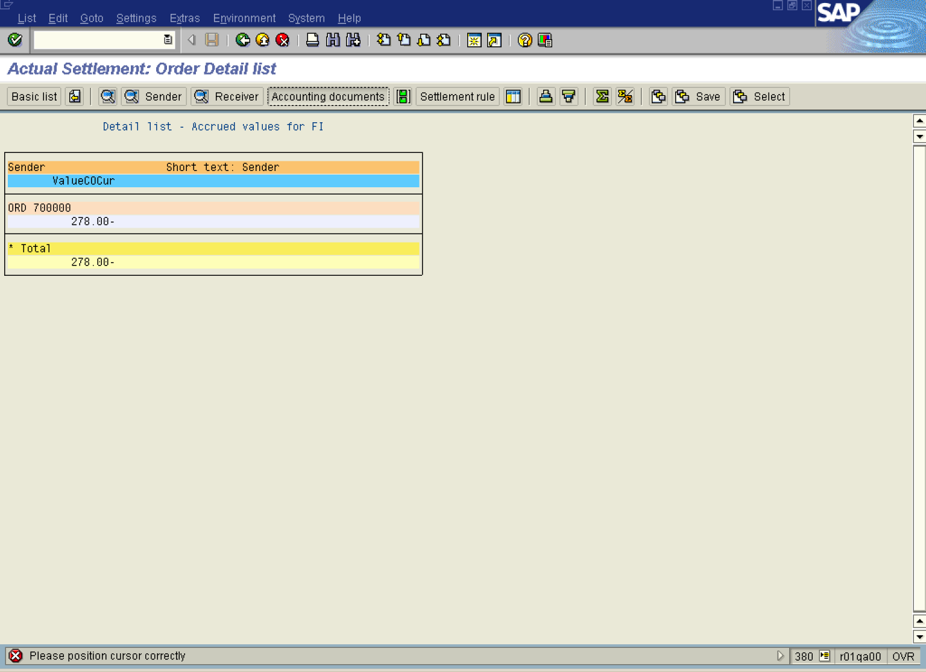

6. Select the relevant line and click the Accounting documents button.

List of Documents in Accounting

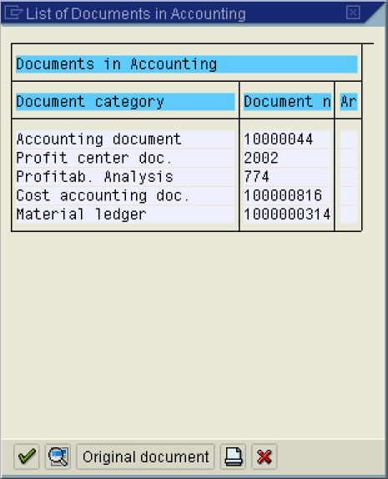

7. Click the Continue button.

Display Document: Overview

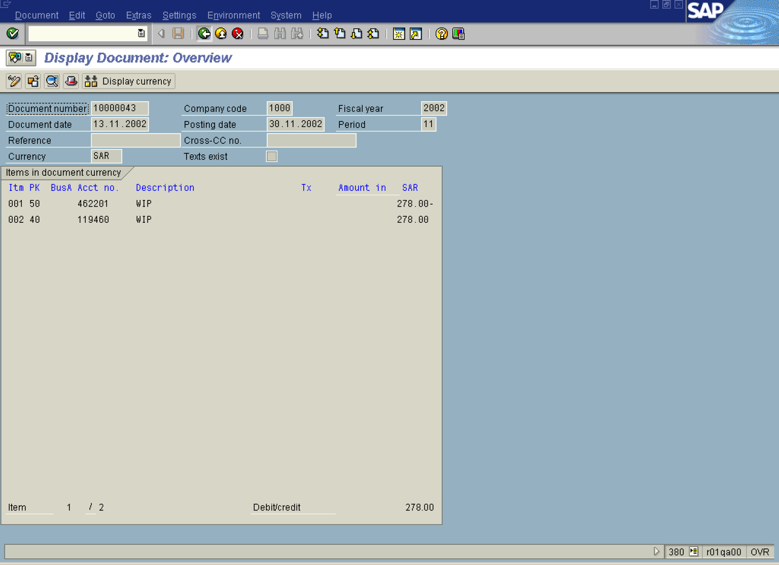

8. Click the Back button.

List of Documents in Accounting

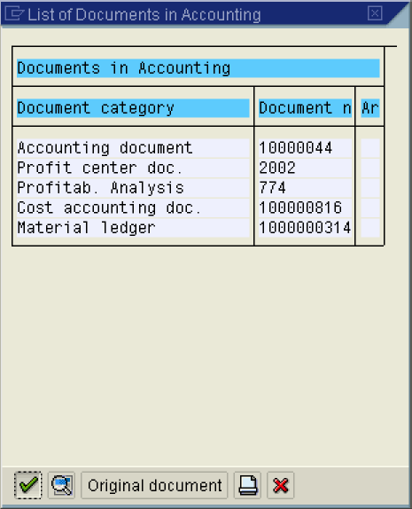

9. Click the Cancel button.

Actual Settlement: Order Detail list

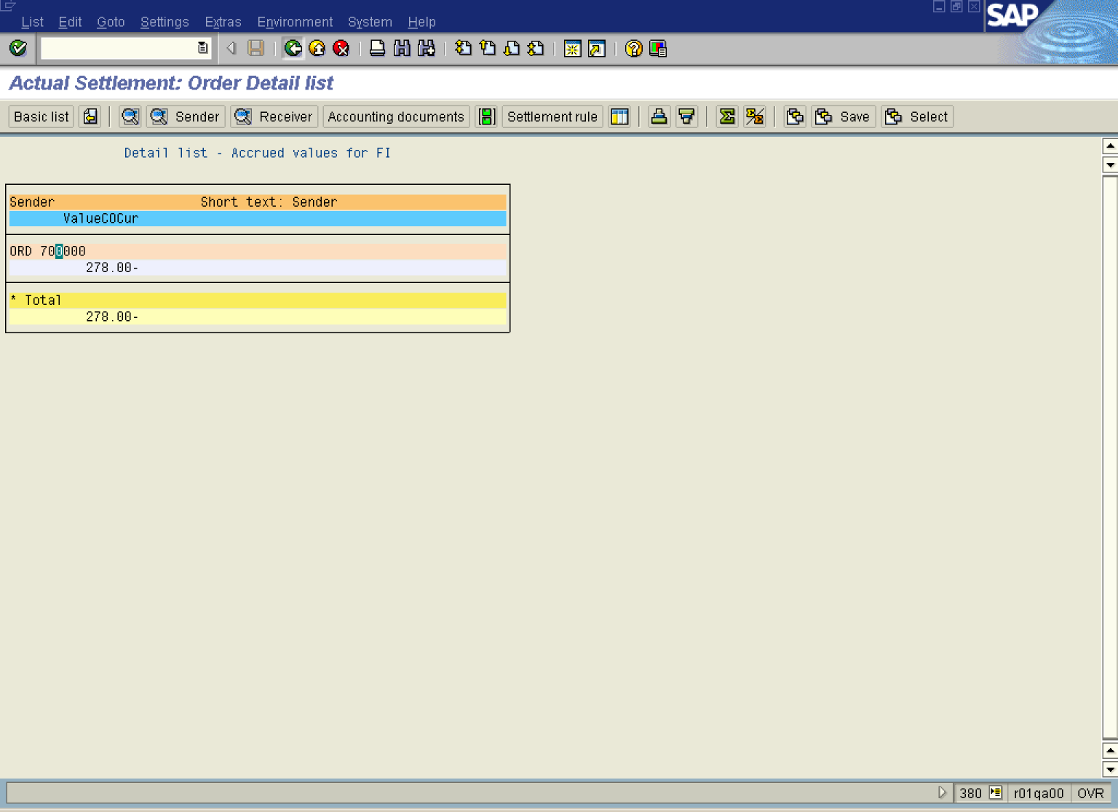

10. Click the Back button.

